AI Game Documentation

Aim: To create a Dot and Box Game.

Algorithm Used:
The minimax algorithm is used in decision-making and game theory for minimizing the possible loss in a worst-case scenario. When dealing with two players, it assumes that the opponent plays optimally to minimize your score. The algorithm works by recursively exploring all possible moves, evaluating the outcomes, and selecting the move that maximizes the player's score while minimizing the opponent's score.
Applying Minimax to Dot and Box
- State Representation:
  - Board: Represent the board as a grid where dots and lines are tracked.
  - Move: A move is drawing a line between two adjacent dots.
  - State: The current configuration of the board and whose turn it is.
- Terminal States:
  - The game ends when all possible lines are drawn and no more moves can be made.
- Evaluation Function:
  - Evaluate the score based on the number of completed boxes. In a more sophisticated implementation, you might consider factors like the number of potential boxes or strategic positioning.
- Minimax Algorithm:
  - Maximize: The algorithm maximizes the score for the player whose turn it is (the maximizing player).
  - Minimize: The opponent tries to minimize the score (the minimizing player).

Program:
from tkinter import *
from tkinter import simpledialog
import numpy as np

size_of_board = 600
number_of_dots = 6
symbol_size = (size_of_board / 3 - size_of_board / 8) / 2
symbol_thickness = 50
dot_color = '#000000'
player1_color = '#0492CF'
player1_color_light = '#67B0CF'
player2_color = '#EE4035'
player2_color_light = '#EE7E77'
Green_color = '#7BC043'
dot_width = 0.25*size_of_board/number_of_dots
edge_width = 0.1*size_of_board/number_of_dots
distance_between_dots = size_of_board / (number_of_dots)

class Dots_and_Boxes():

def __init__(self):
self.window = Tk()
self.window.title('Dots and Boxes')
self.canvas = Canvas(self.window, width=size_of_board, height=size_of_board)
self.canvas.pack()
self.window.bind('<Button-1>', self.click)

self.player1_name = ""
self.player2_name = ""
self.get_player_names()

self.player1_starts = True
self.refresh_board()
self.play_again()

def get_player_names(self):
self.player1_name = simpledialog.askstring("Player 1 Name", "Enter name for Player 1:")
self.player2_name = simpledialog.askstring("Player 2 Name", "Enter name for Player 2:")
if not self.player1_name:
self.player1_name = "Player 1"
if not self.player2_name:
self.player2_name = "Player 2"

def play_again(self):
self.refresh_board()
self.board_status = np.zeros(shape=(number_of_dots - 1, number_of_dots - 1))
self.row_status = np.zeros(shape=(number_of_dots, number_of_dots - 1))
self.col_status = np.zeros(shape=(number_of_dots - 1, number_of_dots))

self.player1_starts = not self.player1_starts
self.player1_turn = not self.player1_starts
self.reset_board = False
self.turntext_handle = []

self.already_marked_boxes = []
self.display_turn_text()

def mainloop(self):
self.window.mainloop()

def is_grid_occupied(self, logical_position, type):
r = logical_position[0]
c = logical_position[1]
occupied = True

if type == 'row' and self.row_status[c][r] == 0:
occupied = False
if type == 'col' and self.col_status[c][r] == 0:
occupied = False

return occupied

def convert_grid_to_logical_position(self, grid_position):
grid_position = np.array(grid_position)
position = (grid_position-distance_between_dots/4)//(distance_between_dots/2)

type = False
logical_position = []
if position[1] % 2 == 0 and (position[0] - 1) % 2 == 0:
r = int((position[0]-1)//2)
c = int(position[1]//2)
logical_position = [r, c]
type = 'row'

elif position[0] % 2 == 0 and (position[1] - 1) % 2 == 0:
c = int((position[1] - 1) // 2)
r = int(position[0] // 2)
logical_position = [r, c]
type = 'col'

return logical_position, type

def mark_box(self):
boxes = np.argwhere(self.board_status == -4)
for box in boxes:
if list(box) not in self.already_marked_boxes and list(box) != []:
self.already_marked_boxes.append(list(box))
color = player1_color_light
self.shade_box(box, color)

boxes = np.argwhere(self.board_status == 4)
for box in boxes:
if list(box) not in self.already_marked_boxes and list(box) != []:
self.already_marked_boxes.append(list(box))
color = player2_color_light
self.shade_box(box, color)

def update_board(self, type, logical_position):
r = logical_position[0]
c = logical_position[1]
val = 1
if self.player1_turn:
val = -1

if c < (number_of_dots - 1) and r < (number_of_dots - 1):
self.board_status[c][r] += val

if type == 'row':
self.row_status[c][r] = 1
if c >= 1:
self.board_status[c - 1][r] += val

elif type == 'col':
self.col_status[c][r] = 1
if r >= 1:
self.board_status[c][r - 1] += val

def is_gameover(self):
return (self.row_status == 1).all() and (self.col_status == 1).all()

def make_edge(self, type, logical_position):
if type == 'row':
start_x = distance_between_dots/2 + logical_position[0]*distance_between_dots
end_x = start_x + distance_between_dots
start_y = distance_between_dots/2 + logical_position[1]*distance_between_dots
end_y = start_y
elif type == 'col':
start_y = distance_between_dots / 2 + logical_position[1] * distance_between_dots
end_y = start_y + distance_between_dots
start_x = distance_between_dots / 2 + logical_position[0] * distance_between_dots
end_x = start_x

if self.player1_turn:
color = player1_color
else:
color = player2_color
self.canvas.create_line(start_x, start_y, end_x, end_y, fill=color, width=edge_width)

def display_gameover(self):
player1_score = len(np.argwhere(self.board_status == -4))
player2_score = len(np.argwhere(self.board_status == 4))

if player1_score > player2_score:
text = f'Winner: {self.player1_name}'
color = player1_color
elif player2_score > player1_score:
text = f'Winner: {self.player2_name}'
color = player2_color
else:
text = 'It\'s a tie'
color = 'gray'

self.canvas.delete("all")
self.canvas.create_text(size_of_board / 2, size_of_board / 3, font="cmr 50 bold", fill=color, text=text)

score_text = 'Scores \n'
self.canvas.create_text(size_of_board / 2, 5 * size_of_board / 8, font="cmr 40 bold", fill=Green_color,
text=score_text)

score_text = f'{self.player1_name}: {player1_score}\n'
score_text += f'{self.player2_name}: {player2_score}\n'

self.canvas.create_text(size_of_board / 2, 3 * size_of_board / 4, font="cmr 30 bold", fill=Green_color,
text=score_text)
self.reset_board = True

score_text = 'Click to play again \n'
self.canvas.create_text(size_of_board / 2, 15 * size_of_board / 16, font="cmr 20 bold", fill="gray",
text=score_text)

def refresh_board(self):
for i in range(number_of_dots):
x = i * distance_between_dots + distance_between_dots / 2
self.canvas.create_line(x, distance_between_dots / 2, x,
size_of_board - distance_between_dots / 2,
fill='gray', dash=(2, 2))
self.canvas.create_line(distance_between_dots / 2, x,
size_of_board - distance_between_dots / 2, x,
fill='gray', dash=(2, 2))

for i in range(number_of_dots):
for j in range(number_of_dots):
start_x = i * distance_between_dots + distance_between_dots / 2
end_x = j * distance_between_dots + distance_between_dots / 2
self.canvas.create_oval(start_x - dot_width / 2, end_x - dot_width / 2, start_x + dot_width / 2,
end_x + dot_width / 2, fill=dot_color,
outline=dot_color)

def display_turn_text(self):
text = f'Next turn: {self.player1_name if self.player1_turn else self.player2_name}'
color = player1_color if self.player1_turn else player2_color

self.canvas.delete(self.turntext_handle)
self.turntext_handle = self.canvas.create_text(size_of_board - 5 * len(text),
size_of_board - distance_between_dots / 8,
font="cmr 15 bold", text=text, fill=color)

def shade_box(self, box, color):
start_x = distance_between_dots / 2 + box[1] * distance_between_dots + edge_width / 2
start_y = distance_between_dots / 2 + box[0] * distance_between_dots + edge_width / 2
end_x = start_x + distance_between_dots - edge_width
end_y = start_y + distance_between_dots - edge_width
self.canvas.create_rectangle(start_x, start_y, end_x, end_y, fill=color, outline='')

def click(self, event):
if not self.reset_board:
grid_position = [event.x, event.y]
logical_position, valid_input = self.convert_grid_to_logical_position(grid_position)
if valid_input and not self.is_grid_occupied(logical_position, valid_input):
self.update_board(valid_input, logical_position)
self.make_edge(valid_input, logical_position)
self.mark_box()
self.refresh_board()
self.player1_turn = not self.player1_turn

if self.is_gameover():
self.display_gameover()
else:
self.display_turn_text()
else:
self.canvas.delete("all")
self.play_again()
self.reset_board = False

game_instance = Dots_and_Boxes()
game_instance.mainloop()

Output:
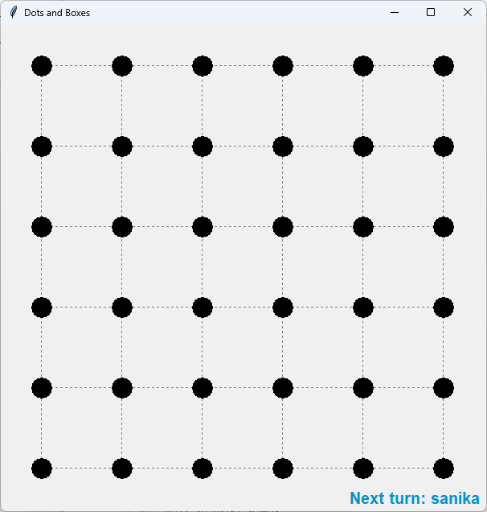
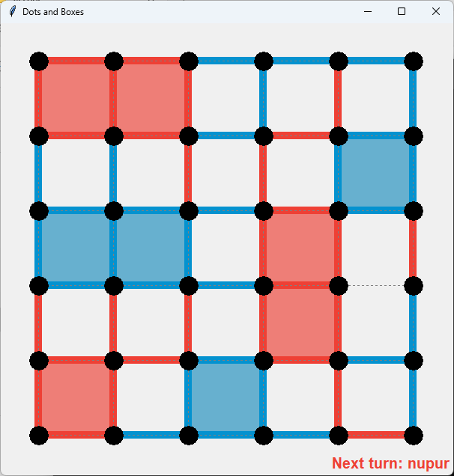
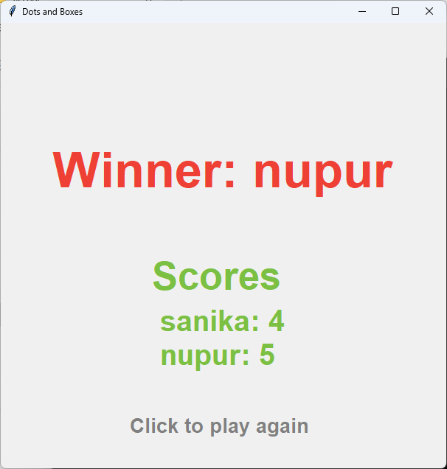

Conclusion: The program to create a Dot and Box Game has been created and executed successfully.

